Catalog Panel (Expanded)
  - Default view. Left catalog panel expanded, right degree plan collapsed but visible
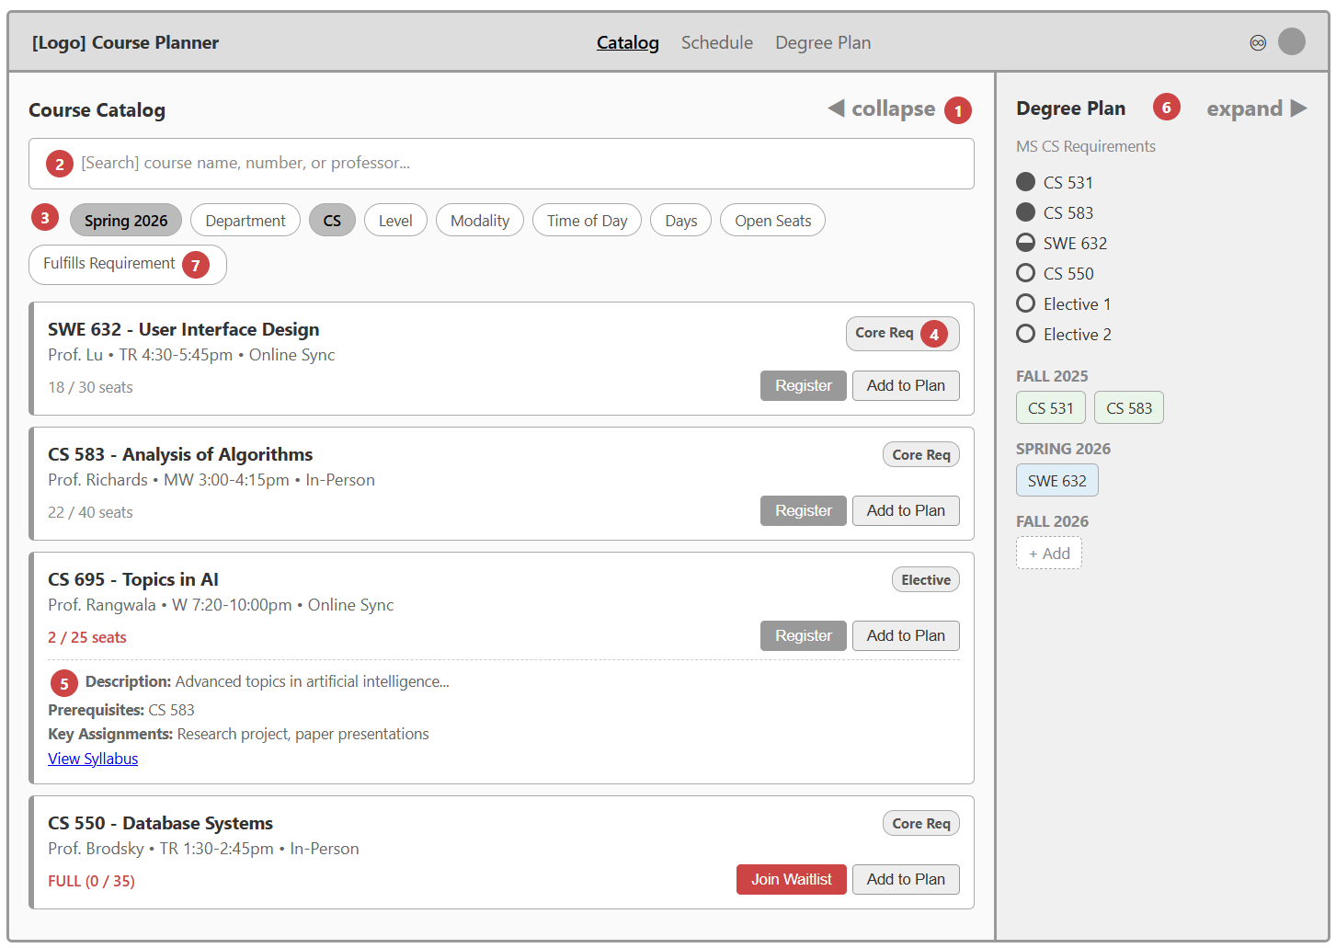
- Progressive Disclosure: Split-panel layout with expand/collapse. Clicking one panel expands it while the other shrinks, keeping both tasks connected without overwhelming the user. The collapsed panel still shows key info at a glance.
- Effective Site Design (Q6: "How can I search?"): Search bar is always visible at the top of the catalog. Users can search by course name, number, or professor. Results replace the list, but active filters still apply on top of search.
- Hierarchy & Information Foraging: Filter chips organize courses by semester, department, level, modality, time, and days. Semester is the most important filter, placed first. Users can narrow results progressively to reduce foraging cost.
- Information Scent: Requirement badges on each class card ("Core Req", "Elective") give users strong cues about how each course fits their degree, without needing to check a separate requirements list.
- Progressive Disclosure (Detail View): Class cards show essential info at a glance (name, professor, time, seats). Clicking a card reveals additional details (description, prerequisites, syllabus). Overview first, details on demand.
- Progressive Disclosure (Collapsed Panel): The degree plan panel stays visible even when collapsed, showing requirement status and semester chips. Users can see their progress without switching views.
- Bridging Panels / Reducing Foraging Cost: The "Fulfills Requirement" filter connects the catalog to the degree plan. Users can filter to show only courses that satisfy a specific unfulfilled requirement, bridging the two panels.

Registration Status (Color System)
  - After registering, cards show status via colored left border. Green = registered, yellow = conflict, red = waitlisted. Inline banners, no popups.
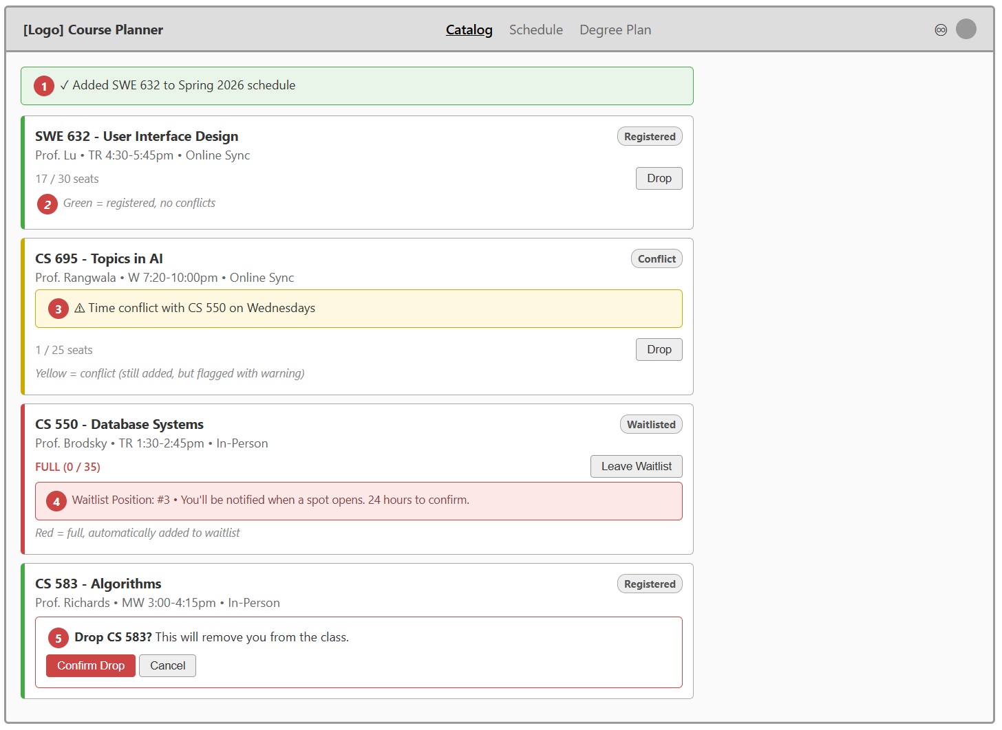
- Interaction Flow Guidelines: Inline confirmation banner appears after registering ("Added to Spring 2026 schedule"). No modal dialog or popup interrupts the user's flow. The user can continue browsing immediately.
- Idiom (Traffic Light Pattern): Green/yellow/red color coding on the left border uses a universally understood pattern. Users learn the system once and can instantly read card status at a glance across the entire interface.
- Interaction Flow Guidelines: Conflict warnings appear inline on the card rather than blocking the action. The class is still added but flagged, letting the user decide whether to keep it. Specific details ("Time conflict with CS 550 on Wednesdays") help the user resolve the issue.
- Anticipating Likely Next Actions: When a class is full, the system automatically places the user on the waitlist instead of just saying "class full." Waitlist position and the 24-hour confirmation window are shown upfront so the user knows what to expect.
- Interaction Flow Guidelines (Proportional Confirmation): Dropping a registered class requires confirmation because it's hard to reverse. Waitlisted and planned classes are removed immediately with no confirmation, since re-adding them is easy. The level of friction matches the cost of the action.

Waitlist Flow
  - When a spot opens, user gets a notification. They have 24 hours to confirm or lose the spot. Waitlisted classes appear on schedule but visually distinct.
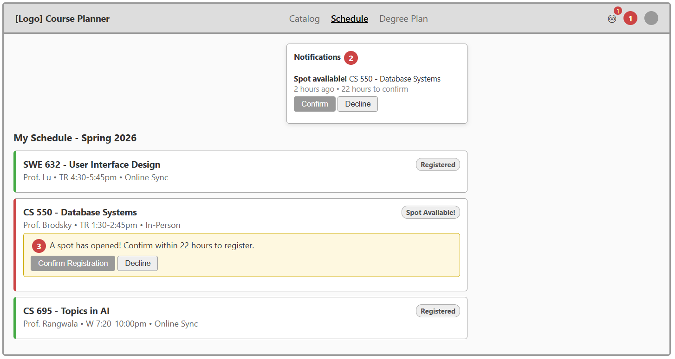
- Effective Site Design: Bell icon with a red badge signals new notifications. The count indicator is visible from any screen, so the user doesn't have to navigate to a specific page to know something needs attention.
- Anticipating Likely Next Actions: The notification dropdown shows the available action (Confirm/Decline) directly inside the notification. The user can act immediately without navigating to another screen. The time remaining (22 hours) creates urgency without being unclear.
- Interaction Flow Guidelines: The same Confirm/Decline action is available both in the notification popup and inline on the class card itself. The user can act from wherever they are. The waitlisted card (red border) remains visually distinct from registered cards (green border) so it's clear which classes are confirmed.

Degree Plan Panel (Expanded)
  - Requirements tracker at top with filled/half/empty circles. Semester timeline below. Clicking an unfulfilled requirement filters the catalog.
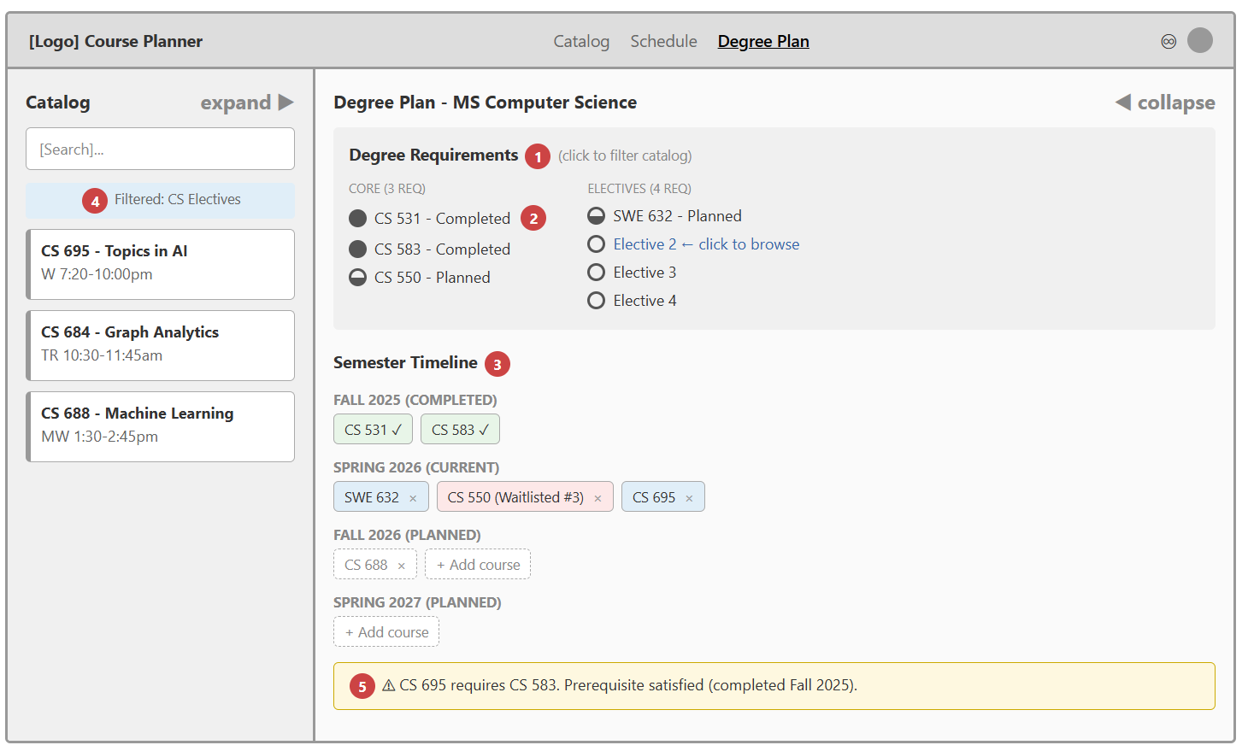
- Anticipating Likely Next Actions: The requirements tracker is interactive. Clicking an unfulfilled requirement (like "Elective 2") automatically filters the catalog panel to show only qualifying courses. This bridges the two panels and saves the user from manually searching.
- Information Scent (Shape-Based Icons): Requirements use filled/half-filled/empty circles instead of colors to show status. This avoids confusion with the green/yellow/red registration color system and works for users with color vision deficiencies. Filled = completed, half-filled = planned, empty = not yet planned.
- Task Structure & Sequencing: Semesters are stacked vertically with earliest at top, latest at bottom. This mirrors the natural timeline of a degree. Class chips within each semester are laid out horizontally, and the X button lets users remove courses from their plan.
- Bridging Panels / Reducing Foraging Cost: When the user clicks an unfulfilled requirement in the degree plan, the collapsed catalog panel updates to show only matching courses. The "Filtered: CS Electives" label confirms the filter is active. Both panels stay visible and connected.
- Preventing Error (Prerequisite Visualization): If a course is placed in a semester, the system checks prerequisites and shows a warning. Here it confirms CS 695's prerequisite (CS 583) was completed. If a prerequisite were missing, the warning would flag the issue before the user tries to register.

Schedule View (Weekly Calendar Toggle)
  - Toggle between semester timeline and weekly calendar. Time blocks show each class. Conflicts highlighted in yellow.
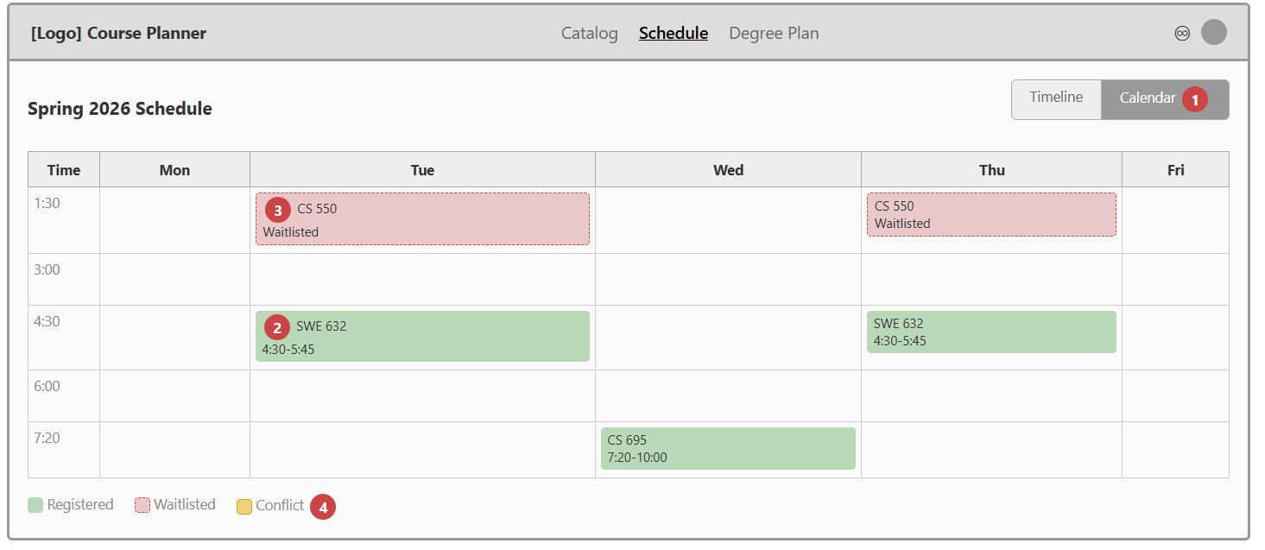
- Flexibility & Efficiency: Toggle button lets users switch between the semester timeline view (all semesters, vertical stack) and a weekly calendar view for a selected semester. Different users prefer different representations of the same data, and both views serve different tasks (long-term planning vs. weekly scheduling).
- Task Structure & Sequencing: Time blocks are laid out on a standard weekly calendar grid with days across the top and times down the left. This helps users see their actual week before committing to registration, making time conflicts spatially obvious.
- Idiom (Visual Distinction): Waitlisted classes appear on the calendar with a dashed border and different background color, visually distinct from registered classes. Users can see where the class would fit in their week even though they're not yet confirmed.
- Preventing Error (Conflict Visibility): If two classes overlap in time, the overlapping blocks are highlighted in yellow with a solid border. The conflict is spatially obvious on the calendar grid, making it hard to miss before the user finalizes their schedule. A legend at the bottom clarifies the color coding.

I used Claude to take the designs I drafted up and make them look cleaner / prettier so that I could focus on the use cases and annotations and not lose detail.

